IBD ANSWERS

Big Data platforms outperform traditional Database Management Systems (DBMS) in several ways, especially when dealing with large-scale, unstructured data. Here’s a justification:

1. **Scalability**: Big Data platforms like Hadoop and Apache Spark can handle vast amounts of data by distributing storage and processing across multiple nodes. Traditional DBMS, such as MySQL or Oracle, are limited in scalability as they rely on vertical scaling, which can be costly.
   * **Example**: Hadoop can process petabytes of data from multiple sources (e.g., social media, IoT devices), whereas a traditional DBMS would struggle to manage data beyond terabytes.
2. **Data Variety**: Big Data platforms can process structured, semi-structured, and unstructured data (e.g., text, images, videos). Traditional DBMS are optimized for structured data, making them less suitable for diverse data types.
   * **Example**: MongoDB, a NoSQL database, can store JSON-like documents, while a relational DBMS would require complex schemas.
3. **Speed and Processing**: Big Data platforms use distributed computing, allowing parallel processing of large datasets. Traditional DBMS can experience slow performance when dealing with complex queries over massive datasets.
   * **Example**: Apache Spark can process large datasets in-memory for faster computations compared to querying a traditional SQL database for the same task.
4. **Cost Efficiency**: Big Data platforms typically use commodity hardware and open-source software, making them more cost-effective. Traditional DBMS often require expensive licensing and high-end hardware.
   * **Example**: Running Hadoop on a cluster of commodity servers is more economical than scaling up a traditional DBMS with proprietary hardware.
5. Big Data platforms provide better performance, flexibility, and cost savings for handling massive, varied data at scale.

2) The **3 Vs** in data analytics are:

1. **Volume**: Refers to the massive amounts of data generated from various sources, such as social media, IoT devices, and transactions. Handling large data volumes requires scalable storage and processing solutions like Hadoop or cloud services.
2. **Velocity**: Describes the speed at which data is generated, processed, and analyzed. In today's world, real-time or near-real-time data processing is essential for timely insights, especially for applications like fraud detection or recommendation engines.
3. **Variety**: Represents the different types of data, including structured (e.g., databases), semi-structured (e.g., JSON files), and unstructured (e.g., videos, text). Data analytics platforms must be capable of handling diverse data formats

**Volume**: Emphasizes the need for systems that can store and process large datasets efficiently, which is critical as data continues to grow exponentially.

**Velocity**: Stresses the importance of handling data in real-time, which is crucial for applications like streaming analytics, financial markets, and emergency response systems.

**Variety**: Highlights the challenge of dealing with different data formats, which requires flexible systems that can process both structured and unstructured data, including multimedia and text.

These three pillars form the foundation for understanding how data is managed and analyzed in modern big data environments. If you're interested in further exploring more aspects, we can discuss advanced techniques or tools used to address each of these challenges.

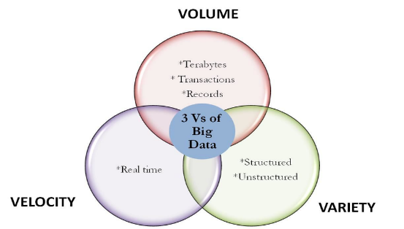

3) **Classification of Big Data Analytics:**

Big Data Analytics can be classified into four main types:

1. **Descriptive Analytics**:
   * Provides insights into past events by summarizing historical data. It helps answer the question, "What happened?"
   * Example: Monthly sales reports or website traffic analysis.
2. **Diagnostic Analytics**:
   * Focuses on understanding why something happened. It uses data mining, correlation, and root cause analysis.
   * Example: Analyzing why a specific product's sales declined over a period.
3. **Predictive Analytics**:
   * Uses historical data, machine learning, and statistical models to predict future outcomes or trends.
   * Example: Predicting customer churn or stock market trends.
4. **Prescriptive Analytics**:
   * Suggests actions based on predictive insights. It helps answer, "What should be done?"
   * Example: Recommending personalized marketing strategies based on customer behavior predictions.

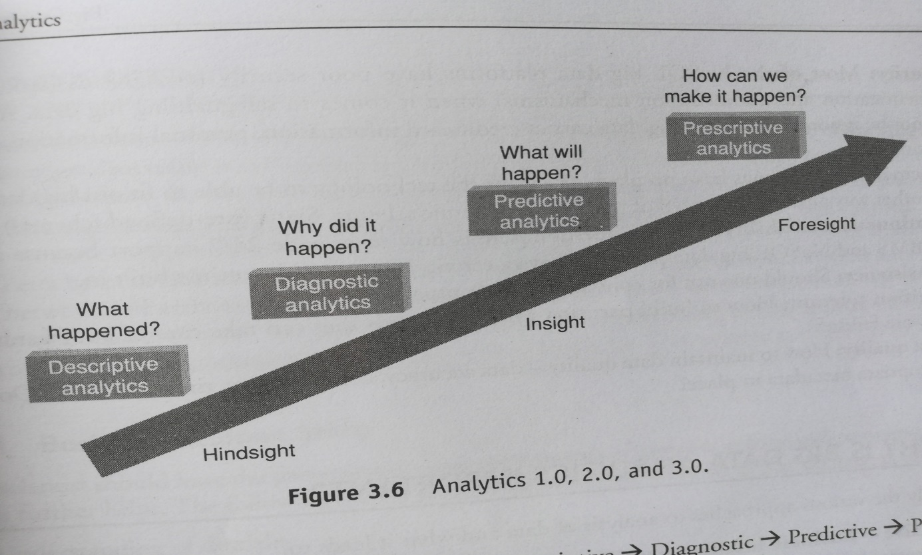

**4) In-memory Analytics (in Big Data Analytics):**

* **Definition**: In-memory analytics refers to analyzing big data directly in RAM, rather than using disk-based storage systems like traditional databases.
* **Role in Big Data**: For big data, where datasets can be enormous, in-memory analytics (e.g., using Apache Spark) speeds up processing by avoiding slow disk I/O operations. It enables faster data exploration, complex computations, and real-time analysis.
* **Key Benefit**: It enhances performance, especially in real-time analytics where decision-making needs to be immediate, such as for fraud detection, stock trading, and dynamic pricing.

**ii. In-database Processing (in Big Data Analytics):**

* **Definition**: In-database processing for big data involves running analytics directly within the database environment, which could be a distributed database or data warehouse.
* **Role in Big Data**: Big data platforms like Google BigQuery or Amazon Redshift allow users to process large datasets within the database itself, removing the need for extracting data to external analytics platforms.
* **Key Benefit**: This reduces data movement and latency, allowing analytics on massive datasets to be conducted more efficiently. It supports scalability and enables handling large-scale analytics workloads without exporting data.

**iii. Symmetric Multiprocessor Systems (SMP) (in Big Data Analytics):**

* **Definition**: SMP systems use multiple processors that share the same memory to handle tasks. In big data analytics, SMP systems allow parallel processing of data, enhancing computational power.
* **Role in Big Data**: SMP systems are often used in big data analytics frameworks to allow for concurrent processing of tasks. With systems like Hadoop or Spark, SMP can improve the speed of data processing by splitting workloads across processors.
* **Key Benefit**: SMP systems help in scaling up big data analytics solutions for high-performance applications, such as large-scale machine learning models, massive data query handling, or simulations.

These technologies improve the speed, efficiency, and scalability of big data analytics, making it possible to process vast datasets and gain insights in a timely manner.

5) Diff between parallel and distributes systems

|  |  |  |  |
| --- | --- | --- | --- |
| |  |  |  | | --- | --- | --- | | **Definition** | Multiple processors work together on the same task, typically within a single machine. | Multiple independent systems work together to solve a task, often over a network. | |
| |  |  |  | | --- | --- | --- | | **Processor Location** | Processors are located within the same physical machine and share memory. | Systems are geographically or logically separated, and each  has its own memory. | |
| |  |  |  | | --- | --- | --- | | **Communication** | Uses shared memory for communication between processors. | Communication happens through message passing over a network. | |
| |  |  |  | | --- | --- | --- | | **Tight/Loose Coupling** | Tightly coupled; processors work closely and communicate frequently. | Loosely coupled; systems are independent and communicate less frequently. | |
| |  |  |  | | --- | --- | --- | | **Scalability** | Limited scalability due to physical hardware constraints (within a single machine). | Highly scalable, as new machines can be added to the network. | |
| |  |  |  | | --- | --- | --- | | **Fault Tolerance** | Lower fault tolerance; if one processor fails, the entire system may be affected. | Higher fault tolerance; failure of one machine does not impact the others. | |
| |  |  |  | | --- | --- | --- | | **Example** | Multi-core processors within a single server. | Cloud computing systems like Google Cloud or AWS. | |
|  |

In summary, parallel systems focus on concurrency within a single machine, while distributed systems coordinate tasks across multiple, independent machines.

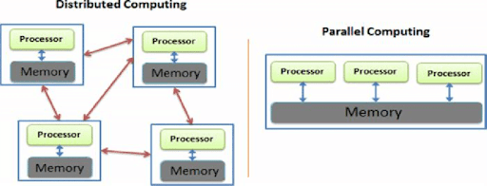

6)Explain the meaning of big data analytics and highlight its key characteristics

Big Data Analytics is the process of examining and interpreting vast amounts of data to uncover hidden patterns, correlations, trends, and insights that can help organizations make data-driven decisions. It involves using advanced analytic techniques, including machine learning, statistical algorithms, and data mining, to process large, diverse, and complex datasets, often in real-time or near-real-time.

**Key Characteristics of Big Data Analytics:**

1. **Volume**:
   * Refers to the enormous amounts of data generated from various sources, such as social media, IoT devices, sensors, and transactions. Big Data Analytics handles and processes terabytes to petabytes of data, often distributed across multiple storage systems.
2. **Velocity**:
   * Describes the speed at which data is generated and must be processed. In Big Data Analytics, real-time or near-real-time data processing is essential for timely decision-making, especially in applications like fraud detection, predictive maintenance, and customer behavior analysis.
3. **Variety**:
   * Refers to the different types of data that can be analyzed, including structured (e.g., relational databases), semi-structured (e.g., XML, JSON), and unstructured data (e.g., text, images, videos). Big Data Analytics must handle diverse data formats and structures to extract meaningful insights.
4. **Veracity**:
   * Concerns the quality and accuracy of the data. Big Data can sometimes be inconsistent, incomplete, or inaccurate. Managing data veracity is critical to ensure reliable analytics and decision-making.
5. **Value**:
   * Highlights the importance of deriving actionable insights from big data. The true value of Big Data Analytics lies in its ability to transform large datasets into valuable insights that can improve business operations, optimize processes, or create new revenue streams.
6. **Scalability**:
   * Big Data Analytics platforms are designed to scale horizontally by adding more nodes or resources to handle increasing data volumes, making it possible to analyze massive datasets efficiently.
7. **Complexity**:
   * Managing and analyzing vast, diverse datasets from multiple sources poses significant complexity. Big Data Analytics uses advanced technologies and algorithms to manage the interrelations between various data sources and provide accurate results.

**Summary:**

Big Data Analytics enables organizations to leverage massive datasets to gain deeper insights, make better decisions, and stay competitive. Its key characteristics—volume, velocity, variety, veracity, value, scalability, and complexity—define its ability to handle complex, fast-moving, and diverse data environments.

7) Illustrate YARN based execution model and its functions With a neat diagram

YARN (Yet Another Resource Negotiator) is a resource management layer in Hadoop that allows for the efficient allocation of system resources across various applications running in a distributed environment. It is responsible for managing computing resources in clusters and scheduling users' applications.

**YARN Architecture and Execution Model:**

YARN divides its responsibilities into the following components:

1. **Resource Manager (RM):**
   * Central authority for resource allocation in the cluster.
   * Divided into two parts:
     + **Scheduler:** Allocates resources to running applications based on the available resources and policies.
     + **Application Manager:** Manages application lifecycles, accepting job submissions, and negotiating the first container for executing the application.
2. **Node Manager (NM):**
   * Runs on each cluster node and is responsible for overseeing resource usage (CPU, memory, disk, etc.) on that node.
   * Communicates with the Resource Manager to report the health status of the node.
3. **Application Master (AM):**
   * Each application has its own Application Master that negotiates resources with the Resource Manager and works with the Node Manager to execute tasks.
   * It is responsible for task execution, fault tolerance, and dynamic resource adjustments.
4. **Container:**
   * A container is a unit of resource allocation in YARN. It includes the resources (memory, CPU, etc.) required by an application. Containers run the actual tasks that are part of a job.

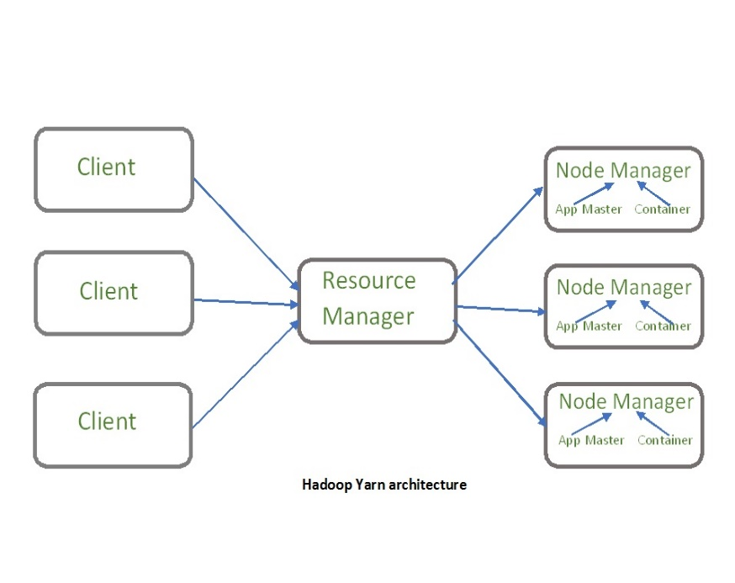

**YARN Execution Workflow:**

1. **Job Submission:**
   * The client submits an application to the Resource Manager, which includes the Application Master and application-specific code.
2. **Application Master Initialization:**
   * The Resource Manager allocates a container for the Application Master, which is then launched on a Node Manager. The Application Master is responsible for requesting resources from the Resource Manager and executing tasks.
3. **Resource Allocation and Task Execution:**
   * The Application Master negotiates with the Resource Manager for more containers to run tasks. Once allocated, it communicates with the corresponding Node Managers to launch the containers and start the tasks.
4. **Task Completion and Monitoring:**
   * The Application Master monitors the progress of the tasks and handles retries in case of failures. It continues until all tasks are completed.
5. **Job Completion:**
   * Once all tasks are finished, the Application Master informs the Resource Manager and then terminates.

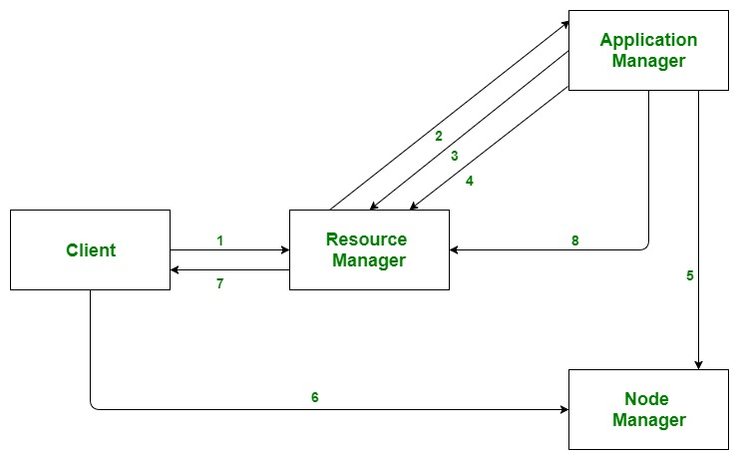

8) Compare and contrast RDBMS and Hadoop in terms of architecture and suitability for handling big data

**Architecture**

* **RDBMS:**
  + **Centralized:** Single server for data management.
  + **Schema-Based:** Data stored in tables with a fixed schema.
  + **ACID Transactions:** Ensures data integrity.
  + **Scaling:** Adds resources to a single server (vertical scaling).
* **Hadoop:**
  + **Distributed:** Uses multiple servers (nodes) for data storage and processing.
  + **Schema-on-Read:** No fixed schema; applied when data is read.
  + **No ACID Support:** Focuses on handling large data volumes.
  + **Scaling:** Adds more servers to the cluster (horizontal scaling).

**Data Handling**

* **RDBMS:**
  + **Structured Data:** Best for well-defined, relational data.
  + **Size:** Suitable for small to medium datasets.
  + **Performance:** Can slow down with very large datasets.
* **Hadoop:**
  + **Varied Data:** Handles structured, semi-structured, and unstructured data.
  + **Size:** Ideal for very large datasets (terabytes to petabytes).
  + **Performance:** Processes large volumes efficiently.

**Data Processing**

* **RDBMS:**
  + **SQL:** Uses SQL for querying and managing data.
  + **Real-Time:** Best for quick, real-time transactions.
* **Hadoop:**
  + **MapReduce:** Processes data in parallel across a cluster.
  + **Batch Processing:** Suited for large-scale data analysis rather than real-time transactions.

**Fault Tolerance**

* **RDBMS:**
  + **Low Fault Tolerance:** Depends on replication and backups; can be vulnerable to server failures.
* **Hadoop:**
  + **High Fault Tolerance:** Automatically replicates data across nodes; can handle node failures without data loss.

**Use Cases**

* **RDBMS:**
  + **Transactional Systems:** Ideal for applications needing quick, reliable transactions (e.g., banking).
* **Hadoop:**
  + **Big Data Analytics:** Best for processing and analyzing massive datasets (e.g., social media, large-scale log analysis).

**9)**Outline the evolution of Hadoop platform and discuss the role of Google, Apache and Yahoo in each stages of development.

**1. Google's Role (Early 2000s):**

* **Google File System (GFS)** and **MapReduce** concepts were developed by Google to handle massive amounts of data.
* These ideas inspired the core of Hadoop.

**2. Yahoo's Role (2005-2011):**

* **Yahoo hired Doug Cutting** (creator of Hadoop) and funded its early development.
* Yahoo used Hadoop to run massive clusters, improving and scaling it for real-world usage.

**3. Apache's Role (2006 and beyond):**

* Hadoop became an **open-source project** under the **Apache Software Foundation**, allowing global collaboration and development.
* Apache ensured Hadoop remained accessible and widely adopted, leading to a thriving ecosystem.

**Key Milestones:**

* **2003-2004**: Google published papers on GFS and MapReduce.
* **2005**: Doug Cutting developed Hadoop at Yahoo.
* **2006**: Hadoop became an Apache project.
* **2008**: Yahoo ran a 10,000-node Hadoop cluster.
* **2012**: Hadoop 2.0 introduced YARN, expanding its capabilities.

In summary:

* **Google** created the ideas.
* **Yahoo** developed and scaled Hadoop.
* **Apache** made it open-source and fostered its growth.

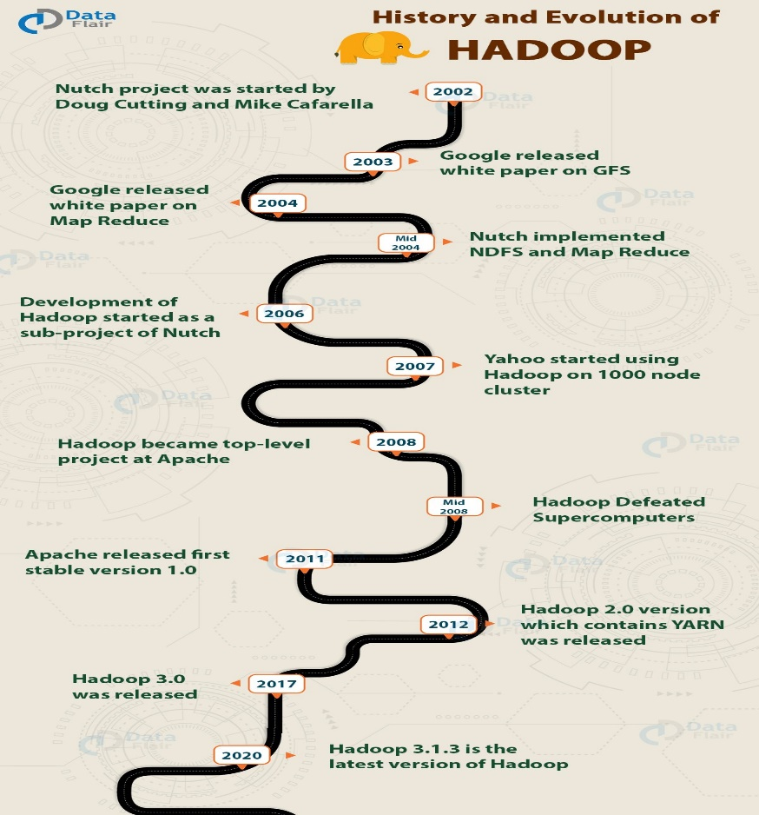

10) Explain the concept of the Hadoop Distributed File System (HDFS). How does it manage data storage in a Hadoop cluster?

The Hadoop Distributed File System (HDFS) is designed to store and manage large datasets across a cluster of computers. Here’s a simple overview:

1. **Distributed Storage:**
   * Files are split into large blocks (e.g., 128 MB) and spread across many nodes.
2. **Replication:**
   * Each block is copied (default is 3 times) to different nodes to ensure data is not lost if a node fails.
3. **Master-Slave Architecture:**
   * **NameNode:** Keeps track of where data blocks are stored and manages metadata.
   * **DataNode:** Stores the actual data blocks and handles read/write requests.
4. **Fault Tolerance:**
   * If a DataNode fails, HDFS replicates its blocks to other nodes to keep data safe.
5. **Write Once, Read Many:**
   * HDFS is optimized for large files that are read multiple times but not frequently changed.
6. **Data Locality:**
   * HDFS tries to store data close to where it will be processed to speed up access.

In summary, HDFS stores large files across multiple machines, ensures data reliability through replication, and is designed to handle failures and large-scale data efficiently.

11)Explain Hadoop ecosystem in detail?

The Hadoop ecosystem is a suite of tools designed to handle big data challenges. Here are its core components:

1. **HDFS (Hadoop Distributed File System)**: Stores large datasets across multiple nodes, using Name Nodes to manage metadata and Data Nodes to store actual data.
2. **YARN (Yet Another Resource Negotiator)**: Manages resources and scheduling in the Hadoop cluster, consisting of Resource Manager, Node Manager, and Application Manager.
3. **MapReduce**: Processes data using parallel algorithms. It involves two functions:
   * **Map()**: Sorts and filters data, generating key-value pairs.
   * **Reduce()**: Aggregates the mapped data into a smaller set.
4. **Pig**: Developed by Yahoo, it uses Pig Latin, a query language similar to SQL, to process and analyze large data sets. It simplifies programming by handling MapReduce tasks behind the scenes.
5. **Hive**: Provides an SQL-like interface (Hive Query Language) for querying large data sets, supporting both real-time and batch processing.
6. **Mahout**: Offers machine learning capabilities with libraries for collaborative filtering, clustering, and classification.
7. **Apache Spark**: A fast processing engine for real-time and iterative tasks, often used alongside Hadoop for optimized performance.
8. **Apache HBase**: A NoSQL database that handles large datasets with capabilities similar to Google’s BigTable, suitable for quick data retrieval and updates.

These components work together to efficiently store, process, and analyze big data.

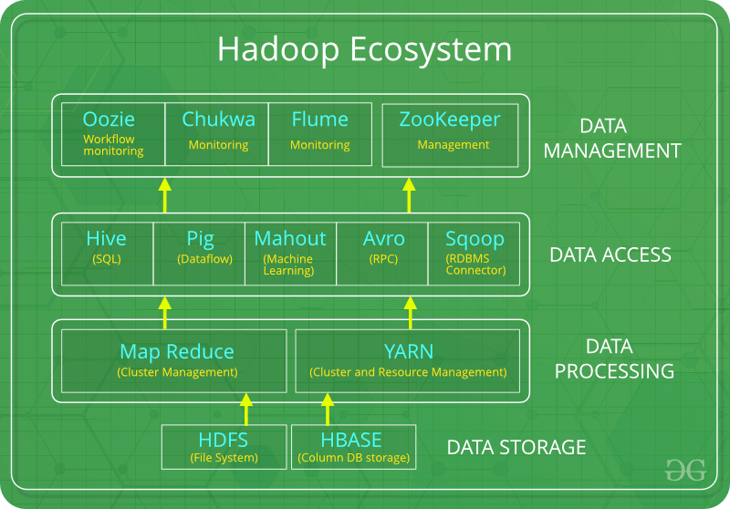

Discuss in detail about the Anatomy of file Write in HDFS.

**Anatomy of File Write in HDFS**

**1. Create File**

* **Action:** Client calls create() on DistributedFileSystem (DFS).
* **HDFS Action:** DFS makes an RPC (Remote Procedure Call) to the NameNode to create the file and check permissions.
* **Outcome:** NameNode confirms file creation and returns an FSDataOutputStream for writing data.

**2. Write Data**

* **Action:** Client writes data to FSDataOutputStream.
* **HDFS Action:** DFSOutputStream splits the data into packets and queues them in an internal "info queue".

**3. Data Pipeline**

* **Action:** DataStreamer requests block allocation from NameNode and sets up a data pipeline with DataNodes.
* **HDFS Action:** The primary DataNode receives packets, stores them, and forwards them to the next DataNode in the pipeline. The pipeline includes multiple DataNodes (e.g., 3 for replication).

**4. Forward Packets**

* **Action:** Each DataNode in the pipeline stores packets and forwards them to the next DataNode.

**5. Acknowledge Receipt**

* **Action:** Packets wait in an "ack queue" until all DataNodes acknowledge receipt.
* **HDFS Action:** DFSOutputStream manages this queue and waits for acknowledgments from all DataNodes.

**6. Complete File Write**

* **Action:** Once all packets are acknowledged, DFS signals the NameNode that the file write is complete.
* **Client:** Starts the file creation and writes data.
* **NameNode:** Manages metadata and allocates blocks.
* **DFSOutputStream:** Handles data writing and packet management.
* **DataStreamer:** Sets up data pipeline with DataNodes.
* **DataNodes:** Store and replicate data blocks.

**Note:** HDFS follows the "Write Once, Read Many" model, meaning files cannot be edited once written but can be appended by reopening the file. This design enhances scalability, availability, and throughput across many clients.

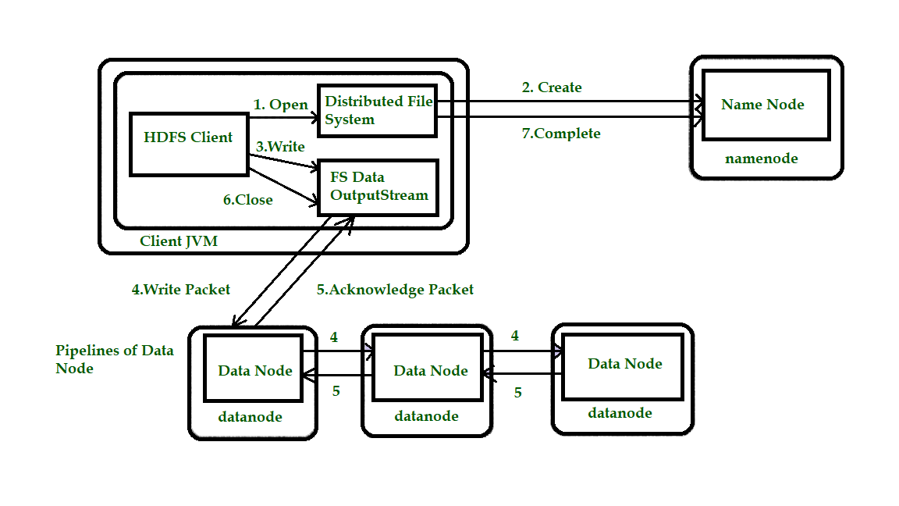

13)Illustrate the phases of Mapper task in Map Reduce Framework.?

**1.Splitting**

1. **Description:** The input data is divided into chunks called splits. Each split is processed by a separate Mapper instance.
2. **Output:** Input splits that are distributed to individual Mapper tasks.

**2.Mapping**

* + **Description:** Each Mapper reads the data from its split and processes it using the user-defined map() function.
  + **Output:** Intermediate key-value pairs are produced as the result of the map() function.

1. **Shuffling**
   * **Description:** After mapping, the framework performs a shuffle operation to group all intermediate values by key. This phase involves sorting and organizing the intermediate data so that all values for a given key are sent to the same Reducer.
   * **Output:** Grouped intermediate key-value pairs that are ready for the Reduce phase.
2. **Sorting**
   * **Description:** The framework sorts the intermediate key-value pairs by key. This sorting is performed within each Reducer to ensure that the keys are processed in a sorted order.
   * **Output:** Sorted key-value pairs, ready for the Reducer.
3. **Partitioning**
   * **Description:** This phase determines which Reducer will receive each key-value pair based on a partitioning function. This helps in distributing the workload among different Reducers.
   * **Output:** Key-value pairs are assigned to specific Reducers.

**Phases Summary:**

1. **Splitting:** Divide input data into manageable chunks.
2. **Mapping:** Process each chunk and emit intermediate key-value pairs.
3. **Shuffling:** Group intermediate pairs by key.
4. **Sorting:** Sort pairs by key.
5. **Partitioning:** Allocate pairs to specific Reducers.

Each phase is essential for ensuring that data is efficiently processed and organized before it reaches the Reducer phase for final aggregation and output.

14) What are the challenges associated with traditional approach of computation and discuss about the advantages of Map Reduce approach

**Challenges of Traditional Computation Approaches**

1. **Scalability:**
   * **Problem:** Hard to add more machines to handle growing data.
   * **Impact:** Can’t manage big data efficiently as it grows.
2. **Fault Tolerance:**
   * **Problem:** If a machine fails, data or processes can be lost.
   * **Impact:** Risk of downtime and data loss.
3. **Data Locality:**
   * **Problem:** Data is often moved across the network for processing.
   * **Impact:** Slow and can cause network bottlenecks.
4. **Complex Parallel Processing:**
   * **Problem:** Difficult to manage multiple tasks at once.
   * **Impact:** Increased development time and complexity.
5. **Handling Large Data Volumes:**
   * **Problem:** Traditional systems struggle with very large datasets.
   * **Impact:** Inefficient processing and high resource use.

**Advantages of MapReduce**

1. **Scalability:**
   * **Benefit:** Easily add more machines to handle more data.
   * **Impact:** Efficiently manages growing datasets.
2. **Fault Tolerance:**
   * **Benefit:** If a machine fails, tasks are automatically reassigned.
   * **Impact:** Reliable processing with minimal downtime.
3. **Data Locality:**
   * **Benefit:** Processes data on the same machine where it’s stored.
   * **Impact:** Reduces network traffic and speeds up processing.
4. **Simplified Parallel Processing:**
   * **Benefit:** Easy to run tasks in parallel with less manual work.
   * **Impact:** Faster development and simpler management.
5. **Handling Large Data Volumes:**
   * **Benefit:** Efficiently processes very large datasets in parallel.
   * **Impact:** Suitable for big data analysis and processing.

16)Explain in detail about Phases of Map( ) and Reduce ( ) Functions with Example.

**Phases of Map and Reduce Functions in MapReduce**

**MapReduce** is a way to process large amounts of data using two main steps: **Map** and **Reduce**.

**1. Map Phase**

**Purpose:** Breaks down input data into smaller chunks and creates intermediate key-value pairs.

**How It Works:**

1. **Input Data:** The data is divided into smaller pieces called splits.
2. **Mapping:** Each piece is processed by a "Mapper" which creates pairs of keys and values.

**Example:**

Imagine we have a bunch of text files, and we want to count how many times each word appears.

**Input Data:**

File 1: "hello world"

File 2: "hello Hadoop"

**Map Function Example:**

def map(key, value):

# Key: filename or line number

# Value: text content

for word in value.split():

emit(word, 1)

**Result:**

* For File 1: ("hello", 1), ("world", 1)
* For File 2: ("hello", 1), ("Hadoop", 1)

**Intermediate Output:**

("hello", 1)

("world", 1)

("hello", 1)

("Hadoop", 1)

**2. Reduce Phase**

**Purpose:** Combines the intermediate key-value pairs to produce the final results.

**How It Works:**

1. **Shuffling and Sorting:** Groups all pairs with the same key together.
2. **Reducing:** Each group is processed by a "Reducer" which combines the values for each key.

**Example:**

**Reduce Function Example:**

def reduce(key, values):

# Key: word

# Values: list of counts

total_count = sum(values)

emit(key, total_count)

**Intermediate Key-Value Pairs for Reduce Phase:**

("hello", [1, 1])

("world", [1])

("Hadoop", [1])

**Final Output:**

* For "hello": 1 + 1 = 2
* For "world": 1
* For "Hadoop": 1

**Final Results:**

("hello", 2)

("world", 1)

("Hadoop", 1)

**Summary**

1. **Map Phase:** Splits data into smaller pieces and creates key-value pairs.
2. **Reduce Phase:** Groups these pairs by key and combines the values to get final results.